
F28DM Database Management Systems
CW1 – Database Design and Implementation
Group 206
- Group number-8
- Amirzhan Adilgereyev
- Kadyrzhan Kuben
- Nursultan Kaiyrbayev
- Yergazy Ubaidolla

HW Motors – Database Design
This document presents the design and implementation of a MariaDB database for HW Motors car and van rental company.

Task 1 – ER Diagram
The ER diagram represents clients, cars, reservations, rental bases, services, insurance choices, and extra drivers. It encompasses derived qualities, specialization, and many-to-many and one-to-many interactions. The conceptual model represents the main business processes of the vehicle rental system. The model includes more than the required minimum of entities and relationships and incorporates advanced ER modelling features. The core entity is CUSTOMER, which stores personal and legal information required to rent vehicles. Each customer can make one or more bookings.
Vehicles are represented by the VEHICLE entity and are categorised using VEHICLE_CATEGORY, which defines business rules such as minimum driver age. Each vehicle belongs to one category and is assigned to a home base as well as a current base, allowing one-way rentals.
The VEHICLE entity is specialised into CAR and VAN using a generalisation hierarchy. These subtypes inherit the primary key from VEHICLE and store attributes specific to each vehicle type.Rental locations are represented by the BASE entity. Each base employs multiple employees and stores operational and contact details.
Employees are modelled using the EMPLOYEE entity. A recursive relationship is used to represent management hierarchy, where an employee may report to another employee.
Seasonal pricing rules are captured using the PRICING_SEASON entity. Vehicle-specific pricing for each season is stored in VEHICLE_PRICING.
The conceptual model includes generalisation, recursive relationships, derived attributes, and associative entities, fully satisfying the advanced ER modelling requirements.

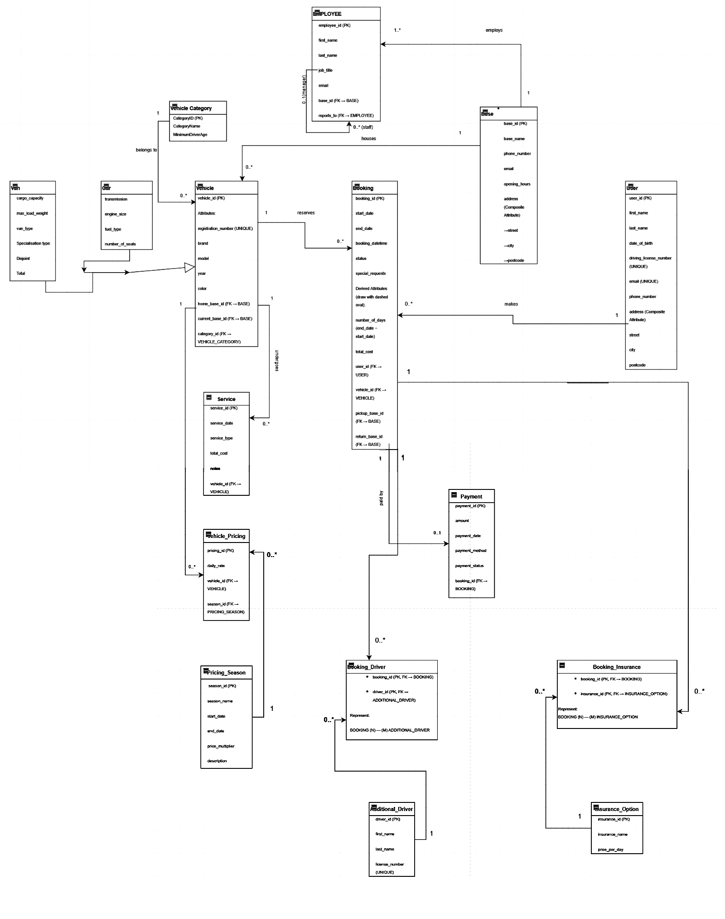

Explanations:

Notation: Following the UML Class Diagram standard, relationships are direct associations with multiplicity (e.g., 1, 0..*) at the ends

- Recursive Relationship: The self-association "supervises" is a part of the EMPLOYEE entity. This makes it possible for a manager (0..1) to oversee several workers (0..*)

- Specialization: The open triangle represents the whole disjoint constraint, and VEHICLE is a supertype with CAR and VAN as subtypes

- Derived Attributes: The rental period and vehicle daily rate are used to generate and calculate attributes like /total_cost

Task 2 – Relational Schema
The ER model was converted into a relational schema with associative tables for many-to-many relationships, primary keys, and foreign keys.
The relational schema was derived from the conceptual ER model while preserving all constraints and relationships.
CUSTOMER
(customer_id PK, first_name, last_name, date_of_birth, email UNIQUE, driving_license_number UNIQUE, phone_number, address)
BASE
(base_id PK, base_name, phone_number, email UNIQUE, opening_hours, address)
VEHICLE_CATEGORY
(category_id PK, category_name, minimum_driver_age)
VEHICLE
(vehicle_id PK, registration_number UNIQUE, brand, model, year, color,
home_base_id FK → BASE(base_id),
current_base_id FK → BASE(base_id),
category_id FK → VEHICLE_CATEGORY(category_id))
CAR
(vehicle_id PK/FK → VEHICLE(vehicle_id), transmission, engine_size, fuel_type, number_of_seats)
VAN
(vehicle_id PK/FK → VEHICLE(vehicle_id), cargo_capacity, max_load_weight, van_type)
BOOKING
(booking_id PK,
customer_id FK → CUSTOMER(customer_id),
vehicle_id FK → VEHICLE(vehicle_id),
pickup_base_id FK → BASE(base_id),
return_base_id FK → BASE(base_id),
start_date, end_date, booking_datetime,
status,
/total_cost (derived))
PAYMENT
(payment_id PK, booking_id FK → BOOKING(booking_id), amount, payment_date, payment_method, payment_status)
EMPLOYEE
(employee_id PK, first_name, last_name, job_title, email UNIQUE,
base_id FK → BASE(base_id),
reports_to FK → EMPLOYEE(employee_id))
SERVICE
(service_id PK, vehicle_id FK → VEHICLE(vehicle_id), service_date, service_type, total_cost, notes)
PRICING_SEASON
(season_id PK, season_name, start_date, end_date, price_multiplier)
VEHICLE_PRICING
(pricing_id PK, vehicle_id FK → VEHICLE(vehicle_id), season_id FK → PRICING_SEASON(season_id), daily_rate)
ADDITIONAL_DRIVER
(driver_id PK, first_name, last_name, license_number UNIQUE)
BOOKING_DRIVER
(booking_id PK/FK → BOOKING(booking_id), driver_id PK/FK → ADDITIONAL_DRIVER(driver_id))
INSURANCE_OPTION
(insurance_id PK, insurance_name, price_per_day)
BOOKING_INSURANCE
(booking_id PK/FK → BOOKING(booking_id), insurance_id PK/FK → INSURANCE_OPTION(insurance_id))

Notes:
All Many-to-Many (M:N) relationships, including the one between Booking and Additional Driver, were transformed into associative tables (e.g., BOOKING_DRIVER) in order to turn the conceptual UML diagram into a relational schema. By setting the Primary Key of the "1" side as a Foreign Key in the "Many" side, one-to-many relationships were established.

Task 3 – MariaDB Implementation
All tables were implemented using the InnoDB engine with appropriate constraints including NOT NULL, UNIQUE, and FOREIGN KEY constraints.
CREATE TABLE CUSTOMER (
customer_id INT AUTO_INCREMENT PRIMARY KEY,
first_name VARCHAR(50) NOT NULL,
last_name VARCHAR(50) NOT NULL,
date_of_birth DATE,
email VARCHAR(100) UNIQUE NOT NULL,
driving_license_number VARCHAR(50) UNIQUE NOT NULL,
phone_number VARCHAR(30),
address VARCHAR(255)
) ENGINE=InnoDB;
CREATE TABLE BASE (
base_id INT AUTO_INCREMENT PRIMARY KEY,
base_name VARCHAR(100),
phone_number VARCHAR(30),
email VARCHAR(100) UNIQUE,
opening_hours VARCHAR(100),
address VARCHAR(255)
) ENGINE=InnoDB;
CREATE TABLE VEHICLE_CATEGORY (
category_id INT AUTO_INCREMENT PRIMARY KEY,
category_name VARCHAR(50),
minimum_driver_age INT
) ENGINE=InnoDB;
CREATE TABLE VEHICLE (
vehicle_id INT AUTO_INCREMENT PRIMARY KEY,
registration_number VARCHAR(50) UNIQUE,
brand VARCHAR(50),
model VARCHAR(50),
year INT,
color VARCHAR(30),
home_base_id INT,
current_base_id INT,
category_id INT,
FOREIGN KEY (home_base_id) REFERENCES BASE(base_id),
FOREIGN KEY (current_base_id) REFERENCES BASE(base_id),
FOREIGN KEY (category_id) REFERENCES VEHICLE_CATEGORY(category_id)
) ENGINE=InnoDB;

CREATE TABLE CAR (
vehicle_id INT PRIMARY KEY,
transmission VARCHAR(30),
engine_size VARCHAR(30),
fuel_type VARCHAR(30),
number_of_seats INT,
FOREIGN KEY (vehicle_id) REFERENCES VEHICLE(vehicle_id)
) ENGINE=InnoDB;

CREATE TABLE VAN (
vehicle_id INT PRIMARY KEY,
cargo_capacity DECIMAL(6,2),
max_load_weight DECIMAL(6,2),
van_type VARCHAR(50),
FOREIGN KEY (vehicle_id) REFERENCES VEHICLE(vehicle_id)
) ENGINE=InnoDB;
CREATE TABLE BOOKING (
booking_id INT AUTO_INCREMENT PRIMARY KEY,
customer_id INT,
vehicle_id INT,
pickup_base_id INT,
return_base_id INT,
start_date DATE,
end_date DATE,
booking_datetime DATETIME DEFAULT CURRENT_TIMESTAMP,
status VARCHAR(20),
FOREIGN KEY (customer_id) REFERENCES CUSTOMER(customer_id) ON UPDATE CASCADE ON DELETE RESTRICT,
FOREIGN KEY (vehicle_id) REFERENCES VEHICLE(vehicle_id) ON UPDATE CASCADE ON DELETE RESTRICT,
FOREIGN KEY (pickup_base_id) REFERENCES BASE(base_id) ON UPDATE CASCADE ON DELETE RESTRICT,
FOREIGN KEY (return_base_id) REFERENCES BASE(base_id) ON UPDATE CASCADE ON DELETE RESTRICT
) ENGINE=InnoDB;

Task 4 – Indexes
Indexes were created to improve performance for vehicle searches, booking date checks, and user authentication.
-- Index 1: Improve retrieval of bookings for a specific user
CREATE INDEX idx_booking_user ON BOOKING(customer_id);
-- Index 2: Speed up search for vehicles at a specific base
CREATE INDEX idx_vehicle_current_base ON VEHICLE(current_base_id);
-- Index 3: Optimise availability checks using date ranges
CREATE INDEX idx_booking_dates ON BOOKING(start_date, end_date);
-- Index 4: Improve performance when identifying the active pricing season
CREATE INDEX idx_pricing_season_dates ON PRICING_SEASON(start_date, end_date);
-- Index 5: Speed up joins between vehicles and seasonal pricing
CREATE INDEX idx_vehicle_pricing_vehicle ON VEHICLE_PRICING(vehicle_id);
Explanations:
- idx_booking_user (on BOOKING table)Reason: This index is essential for the "My Bookings" or "Order History" feature on the website. Without it, the database would have to perform a full table scan of every booking ever made to find those belonging to a specific customer. It ensures that user account pages load instantly.
- idx_vehicle_current_base (on VEHICLE table) Reason: This is the most frequently used index during the customer journey. When a user selects a pickup location (base), the system queries the VEHICLE table for cars where current_base_id matches the selection. This index ensures available cars are displayed without delay.
- idx_booking_dates (on BOOKING table) Reason: To prevent double-booking, the system must check if a vehicle is already reserved within the requested date range. By indexing both start_date and end_date, the database can quickly perform range comparisons, which are computationally expensive without proper indexing.
- idx_pricing_season_dates (on PRICING_SEASON table) Reason: Since rental prices fluctuate based on seasons (e.g., Summer, Christmas), the system constantly checks which season the booking dates fall into. This index optimizes the performance of queries that determine the active pricing multiplier for a specific calendar period.
- idx_vehicle_pricing_vehicle (on VEHICLE_PRICING table) Reason: This index optimizes the JOIN operations between the VEHICLE and VEHICLE_PRICING tables. When calculating the final price for a car, the database needs to find all related pricing records for that specific vehicle_id. This index prevents performance bottlenecks during the checkout process.

